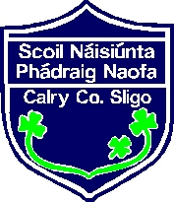
St. Patrick’s N.S. Calry
Junior Infants Booklist 2022/2023

English: Over the Moon – Skills Book-Junior Infants
Jolly Phonics Pupil Book 1 (2020 Edition)
Edco Handwriting Pre-cursive A
Gaeilge: Abair Liom A Second Edition
Maths: Busy at Maths Junior Infants
Religion: Grow in Love Workbook Primary 1–Junior Infants
Copies: 1 Blank copy
1 Project copy
1 A5 Hardback notebook (160 page) (Not Spiral bound)

- 2 Premier Zip Top Folder
- 2 HB Pencils
- 3 Large Pritt Sticks (Please label)
- Scrapbook – size 15’ x 10’
- An old large shirt/t-shirt for art & craft
- Plastic Box for Books (12L)

- Please label all belongings including lunch boxes, water bottles, jumpers & coats.
- Please print your child’s name on the outside cover of all copies and notebook
- Please buy a school bag that the folder and lunch box fits into

- €35 Art & Craft/Photocopying
- €10 Book Rental
- €5 Dabbledoo

Electronic payment
link will
be emailed

Looking forward to seeing everyone in September!
Medb de Buiteléir

